Gasoline Price Increases
By: Monica Hawkins
Email: mh21492p@pace.edu

Abstract
This research forecasts the gasoline price in U.S. and analyzes its managerial implications by means of both univariate and multivariate time series forecasting models. Gasoline price forecast is among the most difficulty time series variables during its importance to the economy and extremely volatile nature. The average regular gasoline price in U.S. reached $5.06 per gallon in the month of June 2022, as opposed to $3.41 at the beginning of 2022, a 48% increase. While gasoline prices had been rising over the first half of 2022 due to supply chain disruptions as a result of global Covid 19 lockdowns and the Russia invasion of Ukraine since February 24, 2022, they then surprisingly came down in the second half of 2022 to $3.85 in November 2022, which has caught many consumers and business organizations off-guard. Both univariate time series forecasting models, such as exponential smoothing and autoregressive integrated moving average, and multivariate time series forecasting models, such as time series regression models, are used in this research with the data for the period January 2002 through November 2022. We find that the time series regression model with trend, season, GDP, CPI, and crude oil price turns out the be the best forecasting model both on the training data and the testing data, even with the testing data containing significant turning points. Managerial implications and future research directions are also discussed

Methodology
Crude oil is located in regions that have been prone historically to political upheaval or have had their oil production disrupted due to political events. Several major oil price shocks have occurred at the same time as supply disruptions triggered by political events, most notably the Arab Oil Embargo in 1973-74, the Iranian revolution and Iran-Iraq war in the late 1970s and early 1980s, and Persian Gulf War in 1990. More recently, disruptions to supply (or curbs on potential development of resources) from political events have been seen in Nigeria, Venezuela, Russia, Iraq, Iran, and Libya.
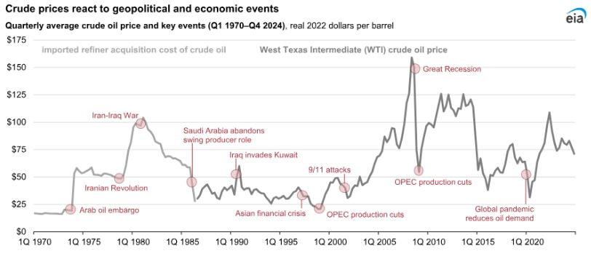
Results
Forecast the average U.S. retail gasoline price to remain near $3.00 per gallon (gal) for the remainder of 2025, resulting in an average 2025 price of $3.10/gal, a 6% decrease from 2024. In 2026, we forecast the average retail gasoline price to fall by 4% to just under $3.00/gal, which would be the lowest annual average price since 2020.
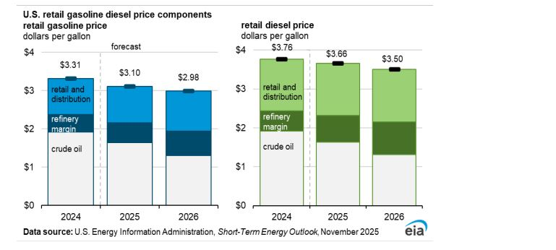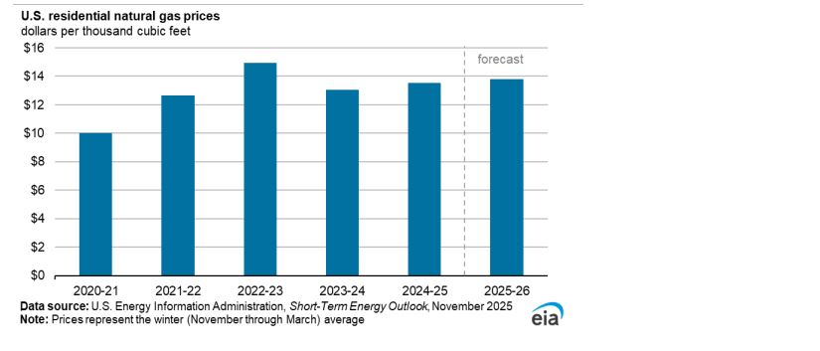
Economic Limitations
Hurricane Katrina in late August, we are reminded of just how important gasoline, diesel fuel, and other petroleum products are to the economy. Although hundreds of miles from the Gulf Coast, the Fifth District region quickly experienced gasoline shortages and soaring prices because of the damage to oil production and refining facilities caused by the storm.
Louisiana’s 17 oil refineries account for nearly one-fifth of the nation’s refining capacity and can process about 3.4 million barrels of crude a day, according to the Energy Information Administration Louisiana is the largest that hold gasoline.
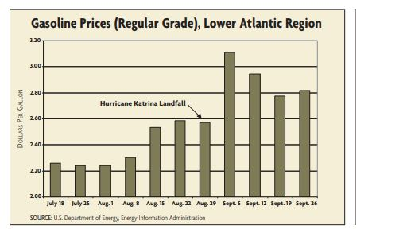
Conclusion
Following the substantial gasoline price increases seen during the spring, summer, and periods of national disaster, consumers are increasingly considering alternatives—most notably, new energy vehicles (NEVs). The significant increase in gasoline prices has the potential to drive consumers toward the adoption of new energy vehicles. However, the reduction in government subsidies may impede consumer behavior toward switching, and the inadequate charging infrastructure in China may also act as a barrier to consumer adoption. The combination of these factors could potentially impact consumer decision making. This study is helpful in analyzing the mechanisms that may affect consumers’ switching to new energy vehicles and in understanding and predicting the changing trends of consumers’ switching intention to new energy vehicles under the impact of multiple factors, which may provide effective countermeasures for the future formulation of relevant policy measures to accelerate the development of new energy vehicles. The SCT modeling results showed that personal factors had a significant positive impact on consumers’ willingness to switch from owning no vehicle or owning a traditional gasoline vehicle to adopting a new energy vehicle. Some variables related to environmental factors had a negative impact on the switching intention.
